I do not wish to receive future

communications from XXXXXX Foodbank

You can change your preferences any time by contacting us on XXXXXXXXXXX or emailing us at XXXX@XXXXXXXXXX.foodbank.org.uk

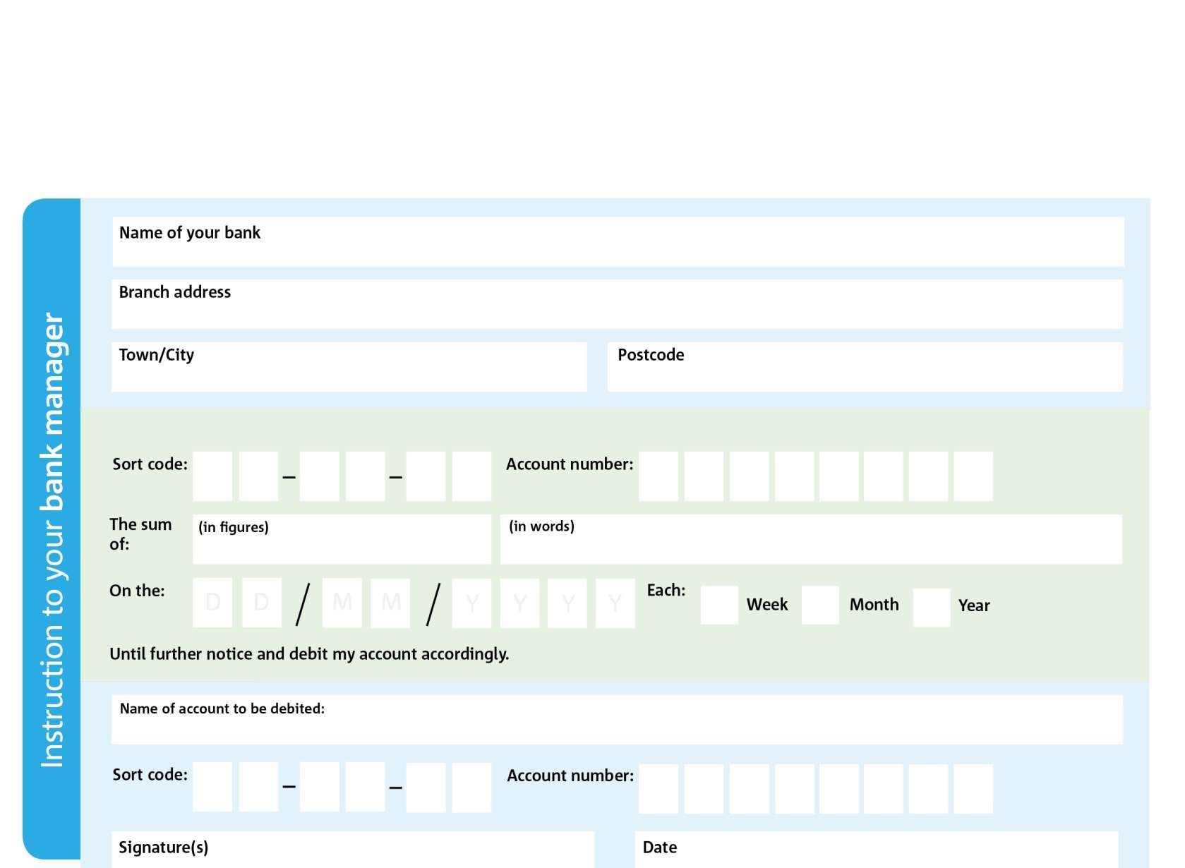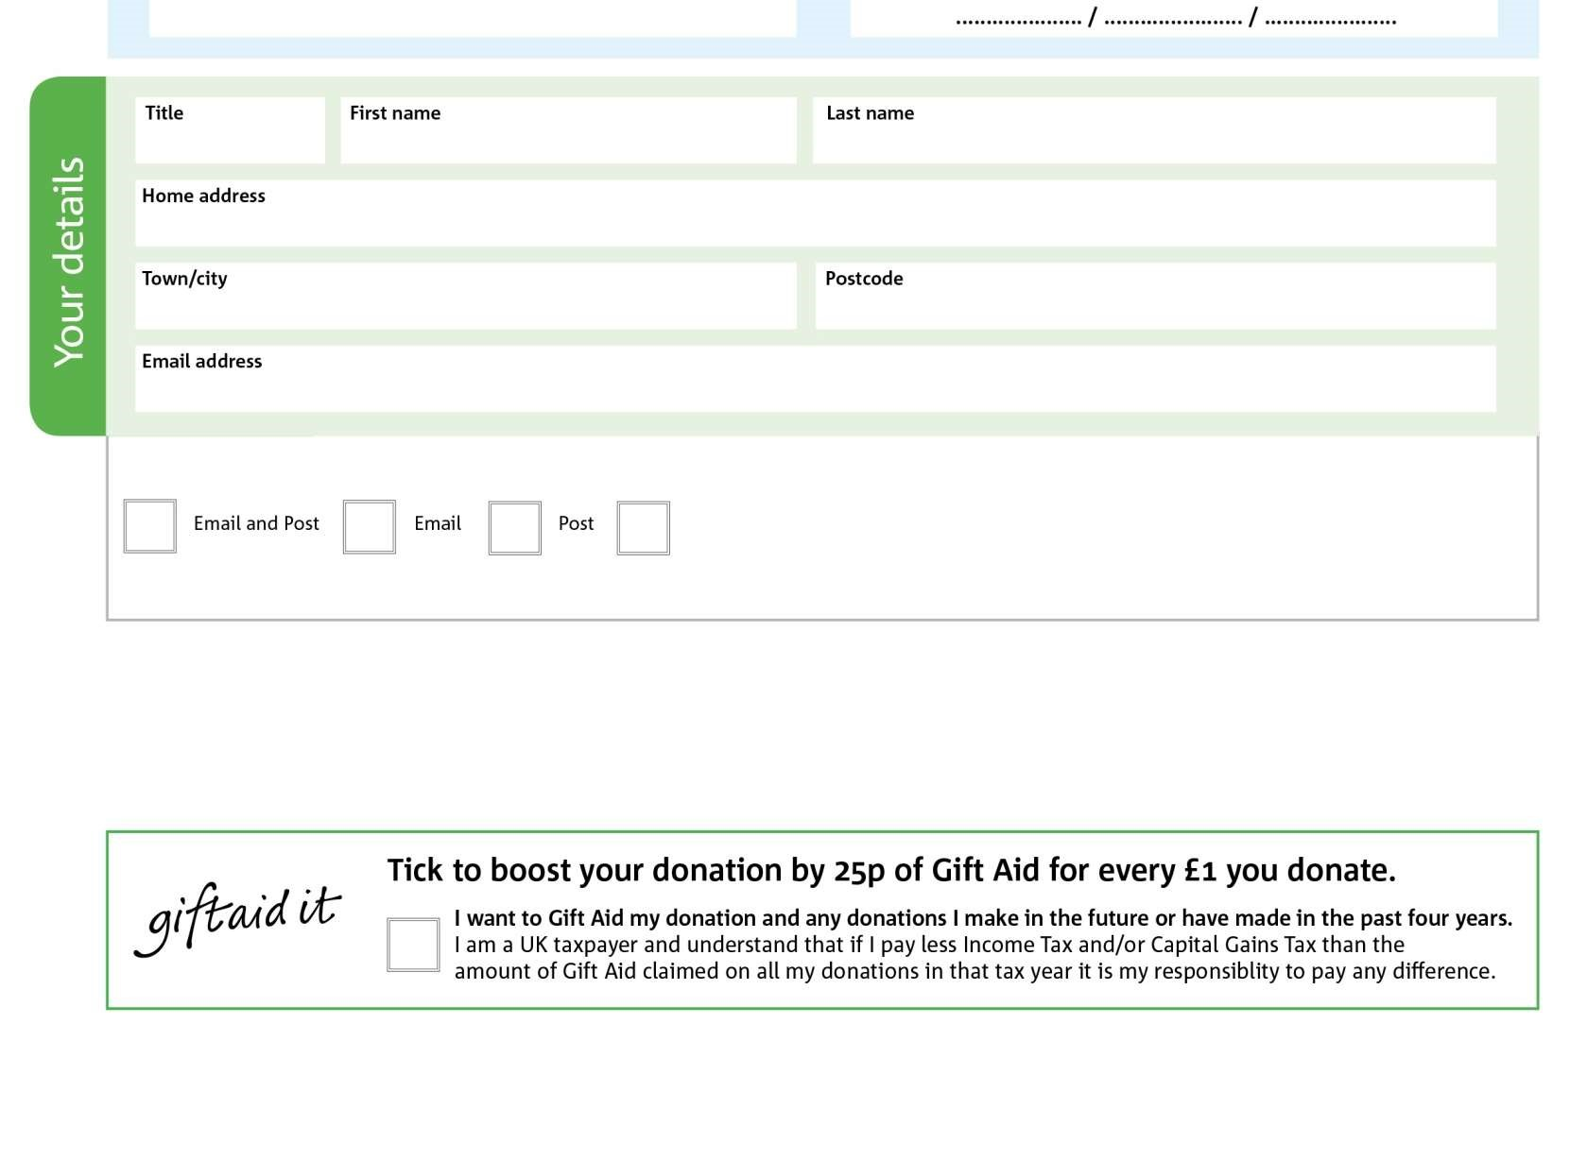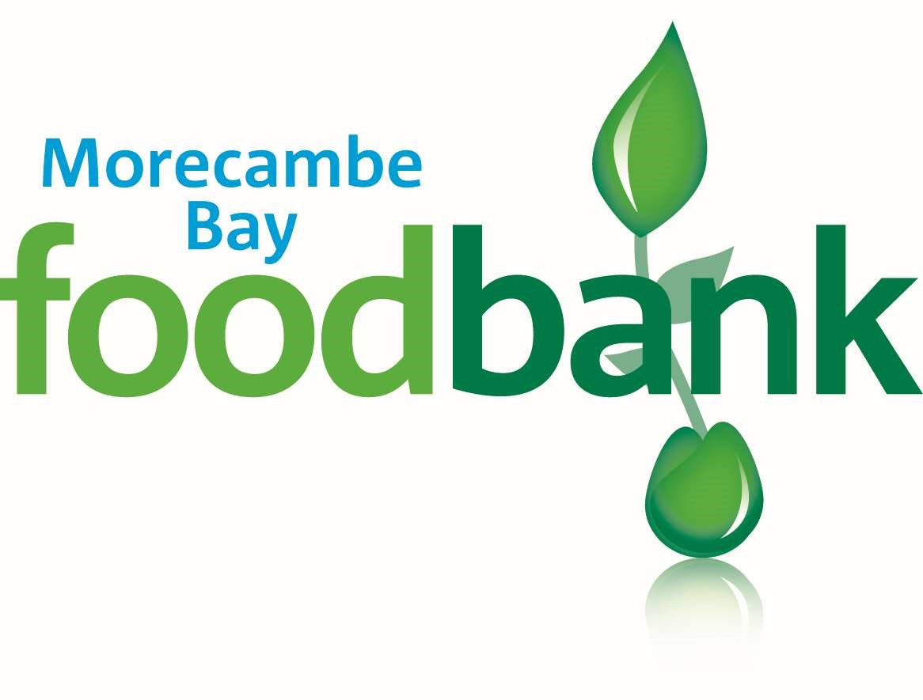

Data protection

‘Morecambe Bay Foodbank is committed to protecting your privacy and will process your personal data in accordance with current Data

Protection legislation. Morecambe Bay Foodbank collects information to keep in touch with you and supply you with information relating to

our work. To unsubscribe from our newsletter, send a message to the email address above with the word unsubscribe in the subject line. Full

data privacy statement for financial donors is available from the

foodbank on request.

’

Reg. Charity No: 1176579 | Reg. in England & Wales

ADDRESS:

b

Morecambe Bay Foodbank, Anchor Building, Westgate, Morecambe, LA3 3DD

,

,

Please pay Morecambe Bay Foodbank,

We would love to keep you up to date with

information about

Morecambe

be Bay

Foodbank. Please tick your preference:

Standing Order Mandate

www.morecambebay.foodbank.org.uk

I do not wish to receive future communications from Morecambe Bay Foodbank

You can change your preferences any time by contacting us on

01524 932001

or emailing us at finance@morecambebay.foodbank.org.uk

0

1

0

5

7

8

4

2

2

0

9

5

5

2

Please pass this form onto the foodbank, using the foodbank’s address at the bottom, who will save a copy for their records.

They will then send it onto your named bank or building society.